## CHAPTER 1:

**INTRODUCTION TO DATABASE MANAGEMENT SYSTEM**

### Introduction

Formally, a "database" refers to a set of related data and the way it is organized. Access to this data is usually provided by a "database management system" (DBMS) consisting of an integrated set of computer software that allows users to interact with one or more databases and provides access to all of the data contained in the database (although restrictions may exist that limit access to particular data). The DBMS provides various functions that allow entry, storage and retrieval of large quantities of information and provides ways to manage how that information is organized. Because of the close relationship between them, the term "database" is often used casually to refer to both a database and the DBMS used to manipulate it.

Outside the world of professional [information technology](https://en.wikipedia.org/wiki/Information_technology), the term *database* is often used to refer to any collection of related data (such as a [spreadsheet](https://en.wikipedia.org/wiki/Spreadsheet) or a card index) as however size and usage requirements typically necessitate use of a database management system. Existing DBMSs provide various functions that allow management of a database and its data which can be classified into four main functional groups:

* **Data definition** – Creation, modification and removal of definitions that define the organization of the data.
* **Update** – Insertion, modification, and deletion of the actual data.
* **Retrieval** – Providing information in a form directly usable or for further processing by other applications. The retrieved data may be made available in a form basically the same as it is stored in the database or in a new form obtained by altering or combining existing data from the database.
* **Administration** – Registering and monitoring users, enforcing data security, monitoring performance, maintaining data integrity, dealing concurrency control, recovering information that has been corrupted by some event such as an unexpected system failure.

Both a database and its DBMS conform to the principles of a particular [database](https://en.wikipedia.org/wiki/Database_model) [model](https://en.wikipedia.org/wiki/Database_model). "Database system" refers collectively to the database model, database management system, and database.

Physically, database [servers](https://en.wikipedia.org/wiki/Server_(computing)) are dedicated computers that hold the actual databases and run only the DBMS and related software. Database servers are usually [multiprocessor](https://en.wikipedia.org/wiki/Multiprocessor) computers, with generous memory and [RAID](https://en.wikipedia.org/wiki/Redundant_array_of_independent_disks) disk arrays used for stable storage. RAID is used for recovery of data if any of the disks fail. Hardware database accelerators, connected to one or more servers via a high-speed channel, are also used in large volume transaction processing environments. DBMSs are found at the heart of most [database applications](https://en.wikipedia.org/wiki/Database_application). DBMSs may be built around a custom [multitasking](https://en.wikipedia.org/wiki/Computer_multitasking) [kernel](https://en.wikipedia.org/wiki/Kernel_(computing)) with built- in [networking](https://en.wikipedia.org/wiki/Computer_network) support, but modern DBMSs typically rely on a standard [operating system](https://en.wikipedia.org/wiki/Operating_system) to provide these functions.

Since DBMSs comprise a significant [market](https://en.wikipedia.org/wiki/Market_(economics)), computer and storage vendors often take into account DBMS requirements in their own development plans.

Databases and DBMSs can be categorized according to the database model(s) that they support (such as relational or XML), the type(s) of computer they run on (from a server cluster to a mobile phone), the [query language](https://en.wikipedia.org/wiki/Query_language)(s) used to access the database (such as SQL or [XQuery](https://en.wikipedia.org/wiki/XQuery)), and their internal engineering, which affects performance, [scalability](https://en.wikipedia.org/wiki/Scalability), resilience, and security.

### History

The sizes, capabilities, and performance of databases and their respective DBMS have grown in orders of magnitude. These performance increases were enabled by the technology progress in the areas of [processors](https://en.wikipedia.org/wiki/Central_processing_unit), [computer memory](https://en.wikipedia.org/wiki/Computer_memory), [computer storage](https://en.wikipedia.org/wiki/Computer_data_storage), and [computer networks](https://en.wikipedia.org/wiki/Computer_network). The development of database technology can be divided into three eras based on data model or structure: [navigational](https://en.wikipedia.org/wiki/Navigational_database), SQL/[relational](https://en.wikipedia.org/wiki/Relational_database), and post- relational. The two main early navigational data models were the [hierarchical model](https://en.wikipedia.org/wiki/Hierarchical_database_model) and the [CODASYL](https://en.wikipedia.org/wiki/CODASYL) model ([network model](https://en.wikipedia.org/wiki/Network_model)).

The [relational model](https://en.wikipedia.org/wiki/Relational_model), first proposed in 1970 by [Edgar F. Codd](https://en.wikipedia.org/wiki/Edgar_F._Codd), departed from this tradition by insisting that applications should search for data by content, rather than by following links. The relational model employs set of ledger-style tables, each used for a

different type of entity. Only in the mid-1980s did computing hardware become powerful enough to allow the wide deployment of relational systems (DBMSs plus applications). By the early 1990s, however, relational systems dominated in all large-scale [data](https://en.wikipedia.org/wiki/Data_processing) [processing](https://en.wikipedia.org/wiki/Data_processing) applications, and as of 2018 they remain dominant: [IBM](https://en.wikipedia.org/wiki/IBM_DB2) [DB2,](https://en.wikipedia.org/wiki/IBM_DB2) [Oracle](https://en.wikipedia.org/wiki/Oracle_database), [MySQL](https://en.wikipedia.org/wiki/MySQL), and [Microsoft SQL Server](https://en.wikipedia.org/wiki/Microsoft_SQL_Server) are the most searched [DBMS](https://en.wikipedia.org/wiki/DBMS)[.[9]](https://en.wikipedia.org/wiki/Database#cite_note-9) The dominant database language, standardized SQL for the relational model, has influenced database languages for other data models.

[Object databases](https://en.wikipedia.org/wiki/Object_database) were developed in the 1980s to overcome the inconvenience of [object-relational impedance mismatch](https://en.wikipedia.org/wiki/Object-relational_impedance_mismatch), which led to the coining of the term "post- relational" and also the development of hybrid [object-relational databases](https://en.wikipedia.org/wiki/Object-relational_database).

The next generation of post-relational databases in the late 2000s became known as [No SQL](https://en.wikipedia.org/wiki/NoSQL) databases, introducing fast [key-value stores](https://en.wikipedia.org/wiki/Key-value_store) and [document-oriented databases.](https://en.wikipedia.org/wiki/Document-oriented_database) A competing "next generation" known as [New SQL](https://en.wikipedia.org/wiki/NewSQL) databases attempted new implementations that retained the relational/SQL model while aiming to match the high performance of No SQL compared to commercially available relational DBMS.

### Characteristics of Database Approach

* + 1. Data redundancy and inconsistency.
    2. Self describing nature of DBMS.
    3. Insulation between programs and data.
    4. Supports multiple views of data.
    5. Sharing of data and multiuser transaction processing.
    6. Restricting unauthorized access.
    7. Provides persistent storage for the program object.
    8. Provides backup and recovery.
    9. Enforcing integrity constraints.
    10. Provides storage structure and search technique for efficient storage processing.

### Application of DBMS

A Database management system is a computerized record-keeping system. It is a repository or a container for collection of computerized data files. The overall purpose of DBMS is to allow the users to define, store, retrieve and update the information contained in the database on demand. Information can be anything that is of significance to an individual or organization.

#### Databases touch all aspects of our lives. Some of the major areas of application are as follows:

* + 1. Banking
    2. Airlines
    3. Universities
    4. Manufacturing and Selling
    5. Human Resources

## CHAPTER 2:

### PURPOSE

**PROJECT DESIGN**

The purpose of this project is to implement or to design a database for an airline reservation system to check the flight details, book and cancel flight tickets. It makes the process of booking and cancelling flight tickets simple and easy for the passengers.

### DESCRIPTION

Airline Reservation System will hold flight schedules and its fare tariffs, passenger reservations and ticket records. It saves time as it allows online procedure as users no longer to wait in a queue to book the flights. It is automatically generated by the server. Admin is the main authority who can do addition, deletion, and modification of flights if required.

The project has been planned to be having the view of distributed architecture, with centralized storage of the database. The application for the storage of the data has been planned. Using the constructs of Database MySQL and all the user interfaces have been designed using the Adobe Dreamweaver technologies. The database connectivity is planned using the “SQL Connection” methodology. The standards of security and data protective mechanism have been given a big choice for proper usage. The application takes care of different modules and their associated reports, which are produced as per the applicable strategies and standards that are put forwarded by the administrative staff.

The entire project has been developed keeping in view of the distributed client server computing technology, in mind. The specification has been normalized up to 2NF to eliminate all the anomalies that may arise due to the database transaction that are executed by the general users and the organizational administration. The user interfaces are browser specific to give distributed accessibility for the overall system. The internal database has been selected as Database MySQL .The Airline Reservation System project is an implementation of a general Airline Ticketing website like Orbitz, which helps the customers to search the availability and prices of various airline tickets, along with the different packages available with the reservations..

## ER DIAGRAM

Fig 2.3 ER DIAGRAM FOR AIRLINE RESERVATIONSYTEM

## SCHEMA DIAGRAM

Schema diagram formulates all the constrains that are to be applied on the data. A database schema defines its entities and the relationship among them. It contains a descriptive detail of the database, which can be depicted by means of schema diagrams.

**Flight**

|  |  |  |  |  |  |
| --- | --- | --- | --- | --- | --- |
| **Book_N** | Cust_id | pswd | Journ_id | Tick_id | Sch_id |

**Schedule**

|  |  |  |  |  |
| --- | --- | --- | --- | --- |
| Sch_id | **Journ_id** | Ddate | DP_Time | Arr_Time |

**Customer**

|  |  |  |  |  |  |  |  |  |
| --- | --- | --- | --- | --- | --- | --- | --- | --- |
| **Cust_Id** | F_name | O_Name | Nation | Residence | Tel_No | E-mail | Pswd | Other_info |

**Ticket**

|  |  |  |  |  |  |
| --- | --- | --- | --- | --- | --- |
| Count | **Tick_Id** | Journ_Id | Fair | Class | Status |

**Journey**

|  |  |  |  |  |
| --- | --- | --- | --- | --- |
| Source | **Journ_id** | Destin | Cost | Route |

Fig 2.4 SCHEMA DIAGRAM FOR AIRLINE RESERVATION SYSTEM

## CHAPTER 3:

**RESOURCE REQUIREMENTS**

### 3.1 Hardware Requirements

* + - **Processor :** Intel CORE i3
    - **RAM :** 4 GB
    - **System type :** 64-bit processor
    - **Monitor :** VGA compatible (CRT or LCD-TFT)

### 3.2 Software Requirements

* + - **XAMPP server**
    - **Front End:** PHP, HTML
    - **Back End:** MYSQL

## CHAPTER 4:

**DESCRIPTION OF TOOLS AND TECHNOLOGIES**

### Description of tools

#### XAMPP Server

XAMPP stands for Cross-Platform (X), Apache (A), Maria DB (M), PHP (P) and Perl (P). Since XAMPP is simple, lightweight Apache distribution it is extremely easy for developers to create a local web server for testing and deployment purposes. Everything you needed is to set up a web server – server application (Apache), database (Maria DB), and scripting language (PHP). XAMPP works equally well on Linux, Mac, and Windows.

#### MySQL SERVER

It is an open-source relational database management system (RDBMS). Its name is a combination of "My", the name of co-founder Michael Widenius 's daughter, and " SQL ", the abbreviation for Structured Query Language. The MySQL development project has made its source code available under the terms of the GNU General Public License, as well as under a variety of proprietary agreements.

MySQL was owned and sponsored by a single for-profit firm, the Swedish company MySQL AB, now owned by Oracle Corporation. For proprietary use, several paid editions are available, and offer additional functionality.

The MySQL server package will install the MySQL database server which can interact with using a MySQL client. User can use the MySQL client to send commands to any MySQL server; on a remote computer The MySQL server is used to persist the data and provide a query interface for it (SQL). The MySQL client’s purpose is to allow you to use that query interface. The client package also comes with utilities that allow ‘s you to easily backup/restore data and administer the server.

### Description of technologies

#### HTML

HTML stands for Hypertext Markup Language, it is the standard markup language for creating web pages and web applications. With Cascading Style Sheets (CSS) and JavaScript it forms a triad of cornerstone technologies for the World Wide Web.

Web browsers receive HTML documents from a web server or from local storage and render them into multimedia web pages. HTML describes the structure of a web page semantically and originally included cues for the appearance of the document.

HTML elements are the building blocks of HTML pages, with HTML constructs, images and other objects, such as interactive forms, may be embedded into the rendered page. It provides a means to create structured documents by denoting structural semantics for text such as headings, paragraphs, lists, links, quotes and other items. HTML elements are delineated by tags, written using angle brackets. Browsers do not display the HTML tags, but use them to interpret the content of the page.

#### Cascading Style Sheets (CSS)

It is a style sheet language used for describing the presentation of a document written in a markup language. Although most often used to set the visual style of web pages and user interfaces written in HTML, the language can be applied to any document, including plain XML, SVG and XUL, and is applicable to rendering in speech, or on other media. Along with HTML and JavaScript, CSS is a cornerstone technology used by most websites to create visually engaging webpages, user interfaces for web applications, and user interfaces for many mobile applications.

CSS is designed primarily to enable the separation of presentation and content, including aspects such as the layout, colors, and fonts. This separation can improve content accessibility, provide more flexibility and control in the specification of presentation characteristics, enable multiple HTML pages to share formatting by specifying the relevant CSS in a separate.css file, and reduce complexity and repetition in the structural content..

#### PHP

It is a server-side scripting language designed primarily for web development but also used as a general-purpose programming language. PHP was originally created by RasmusLerdorf in 1994 the PHP reference implementation is now produced by The PHP Development Team. PHP stands for the acronym: Hypertext Preprocessor.

PHP code may be embedded into HTML or HTML5 markup, or it can be used in combination with various web template systems, web content management systems and web frameworks. PHP code is usually processed by a PHP interpreter implemented as a module in the web server or as a Common Gateway Interface (CGI) executable. The web server software combines the results of the interpreted and executed PHP code, which may be any type of data, including images, with the generated web page. PHP code may also be executed with a command-line interface (CLI) and can be used to implement standalone graphical applications.

## CHAPTER 5:

**IMPLEMENTATION OF CODE**

### Database configuration code

<?php

DEFINE('DB_USER','root');

DEFINE('DB_PASSWORD','');

DEFINE('DB_HOST','localhost');

DEFINE('DB_NAME','airline_reservation');

$dbc=mysqli_connect(DB_HOST,DB_USER,DB_PASSWORD,DB_NAME)

OR dies('Could not connect to MySQL:' .

mysqli_connect_error());

?>

### login page code

<?php

session_start();

?>

<html>

    <head>

        <title>

            Account Login

        </title>

    <link rel="stylesheet" type="text/css" href="css/style.css"/>

        <link rel="stylesheet" href="font-awesome-4.7.0\css\font-awesome.min.css">

    </head>

    <body>

    <h1 id="title" style="color: white;" >

            Airline Reservation System

        </h1>

        <div>

            <ul>

                <li><a href="home_page.php"><i class="fa fa-home" aria-hidden="true"></i> Home</a></li>

                <li><a href="login_page.php"><i class="fa fa-ticket" aria-hidden="true"></i> Book Tickets</a></li>

                <li><a href="aboutus.html"><i class="fa fa-plane" aria-hidden="true"></i> About Us</a></li>

                <li><a href="contactus.html"><i class="fa fa-phone" aria-hidden="true"></i> Contact Us</a></li>

                <li><a href="login_page.php"><i class="fa fa-sign-in" aria-hidden="true"></i> Login</a></li>

            </ul>

        </div>

<br>

        <br>

        <br>

        <form class="float_form" style="padding-left: 600px" action="login_handler.php" method="POST">   <fieldset>

<legend>Login Details:-</legend>

                <strong>Username:</strong><br>

                <input type="text" name="username" placeholder="Enter your username" required><br><br>

                <strong>Password:</strong><br>

                <input type="password" name="password" placeholder="Enter your password" required><br><br>

                <strong>User Type:</strong><br>

                Customer <input type='radio' name='user_type' value='Customer' checked/>

                Administrator <input type='radio' name='user_type' value='Administrator'/>

                <br>

                <?php

                    if(isset($_GET['msg']) && $_GET['msg']=='failed')

                    {

                        echo "<br>

                        <strong style='color:red'>Invalid Username/Password</strong>

                        <br><br>";

                    }

                ?>

                <input type="submit" name="Login" value="Login">

            </fieldset>

            <br>

            <a href="new_user.php"><i class="fa fa-user-plus" aria-hidden="true"></i> Create New User Account?</a>

        </form>

        <div class="container">

    <img src="images/air.jpg" width="100%" style="display: block;">

</div>

    </body>

</html>

### Book ticket code

### <?php

### session_start();

### ?>

### <html>

### <head>

### <title>

### View Available Flights

### </title>

### <link rel="stylesheet" type="text/css" href="css/style.css"/>

### <link rel="stylesheet" href="font-awesome-4.7.0\css\font-awesome.min.css">

### </head>

### <body>

### <div>

### <ul>

### <li><a href="customer_homepage.php"><i class="fa fa-home" aria-hidden="true"></i> Home</a></li>

### <li><a href="customer_homepage.php"><i class="fa fa-desktop" aria-hidden="true"></i> Dashboard</a></li>

### <li><a href="aboutus.html"><i class="fa fa-plane" aria-hidden="true"></i> About Us</a></li>

### <li><a href="contactus.html"><i class="fa fa-phone" aria-hidden="true"></i> Contact Us</a></li>

### <li><a href="logout_handler.php"><i class="fa fa-sign-out" aria-hidden="true"></i> Logout</a></li>

### </ul>

### </div>

### <form action="view_flights_form_handler.php" method="post">

### <h2>SEARCH FOR AVAILABLE FLIGHTS</h2>

### <table cellpadding="5">

### <tr>

### <td class="fix_table">Enter the Origin</td>

### <td class="fix_table">Enter the Destination</td>

### </tr>

### <tr>

### <td class="fix_table">

### <input list="origins" name="origin" placeholder="From" required>

### <datalist id="origins">

### <option value="bangalore">

### </datalist>

### <!-- <input type="text" name="origin" placeholder="From" required> --></td>

### <td class="fix_table">

### <input list="destinations" name="destination" placeholder="To" required>

### <datalist id="destinations">

### <option value="mumbai">

### <option value="mysore">

### <option value="mangalore">

### <option value="chennai">

### <option value="hyderabad">

### </datalist>

### <!-- <input type="text" name="destination" placeholder="To" required> --></td>

### </tr>

### </table>

### <br>

### <table cellpadding="5">

### <tr>

### <td class="fix_table">Enter the Departure Date</td>

### <td class="fix_table">Enter the No. of Passengers</td>

### </tr>

### <tr>

### <td class="fix_table"><input type="date" name="dep_date" min=

### <?php

### $todays_date=date('Y-m-d');

### echo $todays_date;

### ?>

### max=

### <?php

### $max_date=date_create(date('Y-m-d'));

### date_add($max_date,date_interval_create_from_date_string("90 days"));

### echo date_format($max_date,"Y-m-d");

### ?> required></td>

### <td class="fix_table"><input type="number" name="no_of_pass" placeholder="Eg. 5" required></td>

### </tr>

### </table>

### <br>

### <table cellpadding="5">

### <tr>

### <td class="fix_table">Enter the Class</td>

### </tr>

### <tr>

### <td class="fix_table">

### <select name="class">

### <option value="economy">Economy</option>

### <option value="business">Business</option>

### </select>

### </td>

### </tr>

### </table>

### <br>

### <input type="submit" value="Search for Available Flights" name="Search">

### </form>

### <!--Following data fields were empty!

### ...

### ADD VIEW FLIGHT DETAILS AND VIEW JETS/ASSETS DETAILS for ADMIN

### -->->   <div class="container">

### <img src="images/air.jpg" width="100%" style="display: block;">

### </div>

### </body>

### </html>

### Cancel booked tickets code

### <?php

### session_start();

### ?>

### <html>

### <head>

### <title>

### Cancel Booked Tickets

### </title>

### <link rel="stylesheet" type="text/css" href="css/style.css"/>

### <link rel="stylesheet" href="font-awesome-4.7.0\css\font-awesome.min.css">

### </head>

### <body>

### <div>

### <ul>

### <li><a href="customer_homepage.php"><i class="fa fa-home" aria-hidden="true"></i> Home</a></li>

### <li><a href="customer_homepage.php"><i class="fa fa-desktop" aria-hidden="true"></i> Dashboard</a></li>

### <li><a href="aboutus.html"><i class="fa fa-plane" aria-hidden="true"></i> About Us</a></li>

### <li><a href="contactus.html"><i class="fa fa-phone" aria-hidden="true"></i> Contact Us</a></li>

### <li><a href="logout_handler.php"><i class="fa fa-sign-out" aria-hidden="true"></i> Logout</a></li>

### </ul>

### </div>

### <form action="cancel_booked_tickets_form_handler.php" method="post">

### <h2>CANCEL BOOKED TICKETS</h2>

### <?php

### if(isset($_GET['msg']) && $_GET['msg']=='failed')

### {

### echo "<strong style='color: red'>*Invalid PNR, please enter PNR again</strong>

### <br>

### <br>";

### }

### ?>

### <table cellpadding="5" style="padding-left: 30px;">

### <tr>

### <td class="fix_table">Enter the PNR</td>

### </tr>

### <tr>

### <td class="fix_table"><input type="text" name="pnr" required></td>

### </tr>

### </table>

### <br>

### <input type="submit" value="Cancel Ticket" name="Cancel_Ticket">

### </form>

### <div class="container">

### <img src="images/air.jpg" width="100%" style="display: block;">

### </div>

### </body>

### </html>

### Admin home page

### <!DOCTYPE html>

### <html lang="en">

### <head>

### <meta charset="UTF-8">

### <meta name="viewport" content="width=device-width, initial-scale=1.0">

### <title>Welcome Administrator</title>

### <link rel="stylesheet" type="text/css" href="css/style.css" />

### <link rel="stylesheet" href="font-awesome-4.7.0\css\font-awesome.min.css">

### </head>

### <body>

### <img class="logo" src="images/shutterstock_22.jpg" />

### <h1 id="title" style="color: darkblue;" >

### Airline Reservation System

### </h1>

### <div>

### <ul>

### <li><a href="admin_homepage.php"><i class="fa fa-home" aria-hidden="true"></i> Home</a></li>

### <li><a href="admin_homepage.php"><i class="fa fa-desktop" aria-hidden="true"></i> Dashboard</a></li>

### <li><a href="logout_handler.php"><i class="fa fa-sign-out" aria-hidden="true"></i> Logout</a></li>

### </ul>

### </div>

### <h2>Welcome Administrator!</h2>

### <table>

### <tr>

### <td class="admin_func"><a href="admin_view_booked_tickets.php"><i class="fa fa-plane" aria-hidden="true"></i>

### View List of Booked Tickets for a Flight</a>

### </td>

### </tr>

### <tr>

### <td class="admin_func"><a href="add_flight_details.php"><i class="fa fa-plane" aria-hidden="true"></i>

### Add Flight Schedule Details</a>

### </td>

### </tr>

### <tr>

### <td class="admin_func"><a href="delete_flight_details.php"><i class="fa fa-plane" aria-hidden="true"></i>

### Delete Flight Schedule Details</a>

### </td>

### </tr>

### </table>

### <div class="container">

### <img src="images/air.jpg" width="100%" style="display: block;">

### </div>

### </body>

### </html>

### Admin view booked tickets

### <?php

### session_start();

### ?>

### <html>

### <head>

### <title>

### View Booked Tickets

### </title>

### <link rel="stylesheet" type="text/css" href="css/style.css"/>

### <link rel="stylesheet" href="font-awesome-4.7.0\css\font-awesome.min.css">

### </head>

### <body>

### <img class="logo" src="images/shutterstock_22.jpg" />

### <h1 id="title" style="color: darkblue;" >

### Airline Reservation System

### </h1>

### <div>

### <ul>

### <li><a href="admin_homepage.php"><i class="fa fa-home" aria-hidden="true"></i> Home</a></li>

### <li><a href="admin_homepage.php"><i class="fa fa-desktop" aria-hidden="true"></i> Dashboard</a></li>

### <li><a href="logout_handler.php"><i class="fa fa-sign-out" aria-hidden="true"></i> Logout</a></li>

### </ul>

### </div>

### <form action="admin_view_booked_tickets_form_handler.php" method="post">

### <h2>VIEW LIST OF BOOKED TICKETS FOR A FLIGHT</h2>

### <div>

### <table cellpadding="5">

### <tr>

### <td class="fix_table">Enter the Flight No.</td>

### <td class="fix_table">Enter the Departure Date</td>

### </tr>

### <tr>

### <td class="fix_table"><input type="text" name="flight_no" required></td>

### <td class="fix_table"><input type="date" name="departure_date" required></td>

### </tr>

### </table>

### <br>

### <br>

### <input type="submit" value="Submit" name="Submit">

### </div>

### </form>

### <div class="container">

### <img src="images/air.jpg" width="100%" style="display: block;">

### </div>

### </body>

### </html>

### Admin add flight details

### <?php

### session_start();

### ?>

### <html>

### <head>

### <title>

### Add Flight Schedule Details

### </title>

### <link rel="stylesheet" type="text/css" href="css/style.css"/>

### <link rel="stylesheet" href="font-awesome-4.7.0\css\font-awesome.min.css">

### </head>

### <body>

### <img class="logo" src="images/shutterstock_22.jpg" />

### <h1 id="title" style="color: darkblue;" >

### Airline Reservation System

### </h1>

### <div>

### <ul>

### <li><a href="admin_homepage.php"><i class="fa fa-home" aria-hidden="true"></i> Home</a></li>

### <li><a href="admin_homepage.php"><i class="fa fa-desktop" aria-hidden="true"></i> Dashboard</a></li>

### <li><a href="logout_handler.php"><i class="fa fa-sign-out" aria-hidden="true"></i> Logout</a></li>

### </ul>

### </div>

### <form action="add_flight_details_form_handler.php" method="post">

### <h2>ENTER THE FLIGHT SCHEDULE DETAILS</h2>

### <?php

### if(isset($_GET['msg']) && $_GET['msg']=='success')

### {

### echo "<strong style='color: green'>The Flight Schedule has been successfully added.</strong>

### <br>

### <br>";

### }

### else if(isset($_GET['msg']) && $_GET['msg']=='failed')

### {

### echo "<strong style='color: red'>*Invalid Flight Schedule Details, please enter again.</strong>

### <br>

### <br>";

### }

### ?>

### <table cellpadding="4">

### <tr>

### <td class="fix_table">Flight Number</td><td class="fix_table">Jet ID</td></tr>

### <tr><td class="fix_table"><input type="text" name="flight_no" required></td>

### 

### <td class="fix_table">

### <input type="text" name="jet_id" required>

### </td>

### </tr>

### </table>

### <br>

### <hr>

### <table cellpadding="5">

### <tr>

### <td class="fix_table">Origin</td>

### <td class="fix_table">Destination</td>

### </tr>

### <tr>

### <td class="fix_table"><input type="text" name="origin" required></td>

### <td class="fix_table"><input type="text" name="destination" required></td>

### </tr>

### </table>

### <br>

### <hr>

### <table cellpadding="5">

### <tr>

### <td class="fix_table">Departure Date</td>

### <td class="fix_table">Arrival Date</td>

### </tr>

### <tr>

### <td class="fix_table"><input type="date" name="dep_date" required></td>

### <td class="fix_table"><input type="date" name="arr_date" required></td>

### </tr>

### </table>

### <br>

### <hr>

### <table cellpadding="5">

### <tr>

### <td class="fix_table">Departure Time</td>

### <td class="fix_table">Arrival Time</td>

### </tr>

### <tr>

### <td class="fix_table"><input type="time" name="dep_time" required></td>

### <td class="fix_table"><input type="time" name="arr_time" required></td>

### </tr>

### </table>

### <br>

### <hr>

### <table cellpadding="5">

### <tr>

### <td class="fix_table">Number of Seats in Economy Class</td>

### <td class="fix_table">Number of Seats in Business Class</td>

### </tr>

### <tr>

### <td class="fix_table"><input type="number" name="seats_eco" required></td>

### <td class="fix_table"><input type="number"" name="seats_bus" required></td>

### </tr>

### </table>

### <br>

### <hr>

### <table cellpadding="5">

### <tr>

### <td class="fix_table">Ticket Price(Economy Class)</td>

### <td class="fix_table">Ticket Price(Business Class)</td>

### </tr>

### </table>

### <table cellpadding="5">

### <tr>

### <td class="fix_table">

### <input type="number" name="price_eco" required>

### </td>

### <td class="fix_table">

### <input type="number" name="price_bus" required>

### </td>  </tr>

### </table>

### <br>

### <hr>

### <br>

### <input type="submit" value="Submit" name="Submit">

### </form>

### <div class="container">

### <img src="images/air.jpg" width="100%" style="display: block;">

### </div>

### </body>

### </html>

### Admin delete flight details

### <?php

### session_start();

### ?>

### <html>

### <head>

### <title>

### Delete Flight Schedule Details

### </title>

### <link rel="stylesheet" type="text/css" href="css/style.css"/>

### <link rel="stylesheet" href="font-awesome-4.7.0\css\font-awesome.min.css">

### </head>

### <body>

### <img class="logo" src="images/shutterstock_22.jpg" />

### <h1 id="title" style="color: darkblue;" >

### Airline Reservation System

### </h1>

### <div>

### <ul>

### <li><a href="admin_homepage.php"><i class="fa fa-home" aria-hidden="true"></i> Home</a></li>

### <li><a href="admin_homepage.php"><i class="fa fa-desktop" aria-hidden="true"></i> Dashboard</a></li>

### <li><a href="logout_handler.php"><i class="fa fa-sign-out" aria-hidden="true"></i> Logout</a></li>

### </ul>

### </div>

### <form action="delete_flight_details_form_handler.php" method="post">

### <h2>ENTER THE FLIGHT SCHEDULE TO BE DELETED</h2>

### <div>

### <?php

### if(isset($_GET['msg']) && $_GET['msg']=='success')

### {

### echo "<strong style='color:green; padding-left:20px;'>The Flight Schedule has been successfully deleted.</strong>

### <br>

### <br>";

### }

### else if(isset($_GET['msg']) && $_GET['msg']=='failed')

### {

### echo "<strong style='color:red; padding-left:20px;'>*Invalid Flight No./Departure Date, please enter again.</strong>

### <br>

### <br>"; }

### ?>

### <table cellpadding="5" style="padding-left: 20px;">

### <tr>

### <td class="fix_table">Enter a valid Flight No.</td>

### <td class="fix_table">Enter the Departure Date</td>

### </tr>

### <tr>

### <td class="fix_table"><input type="text" name="flight_no" required></td>

### <td class="fix_table"><input type="date" name="departure_date" required></td>

### </tr>

### </table>

### <br>

### <br>

### <input type="submit" value="Delete" name="Delete">

### </div>

### </form>

### <div class="container">

### <img src="images/air.jpg" width="100%" style="display: block;">

### </div>

### </body>

### </html>

|  |  |  |  |  |
| --- | --- | --- | --- | --- |
| Sl.no | Input | Expected Output | ActualOutput | Remarks |
| 1 | ExampleEnter login mail idEnter Password | If Mail id and password is valid login to Main pageIf Mail id and password is not valid It shows pop up message to enter correct mail id and password | If Mail id and password is valid login to Main pageRemains in the same page | YesNO |
| 2 |  |  |  |  |
| 3 |  |  |  |  |
| 4 |  |  |  |  |
| 5 |  |  |  |  |

**TEST CASES**

## CHAPTER 6:

**RESULTS**

**6.1 Login page**

### C:\Users\USER\OneDrive\Pictures\Screenshots\2024-03-03 (3).png

**Fig6.1** Login page of project

#### 6.2 Home page

#### C:\Users\USER\OneDrive\Pictures\Screenshots\2024-03-03 (4).png

**Fig6.2** Home page

### 6.3 Register page

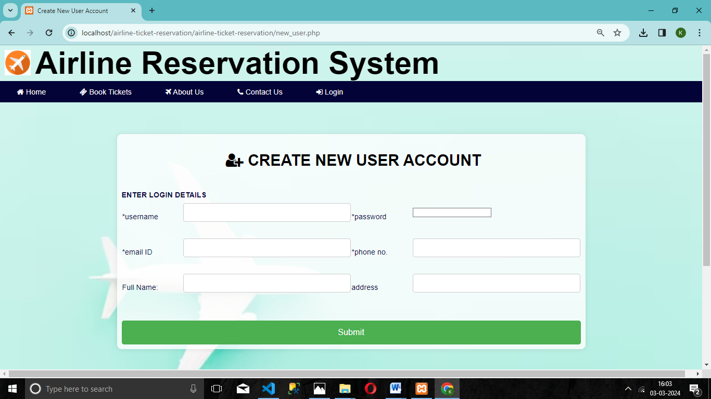

**6.4 Book ticket page**

**Fig6.3** Register page

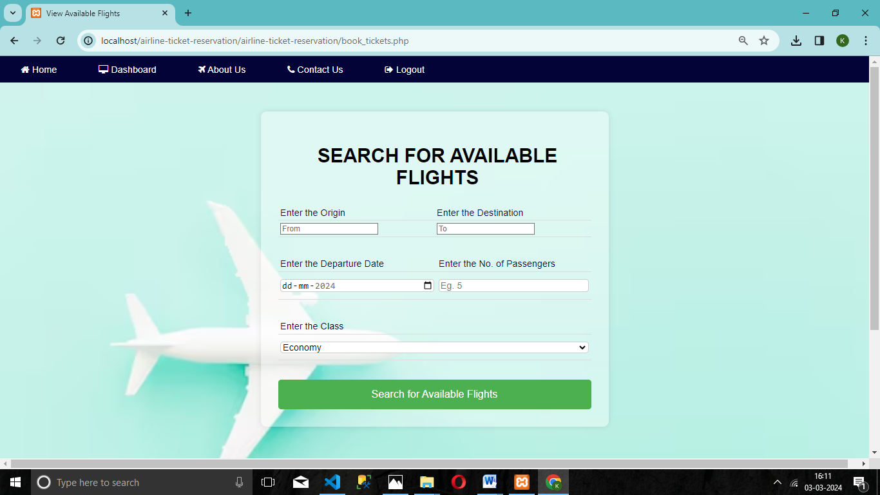

**Fig6.4** Book ticket page

**6.5View flight details page**

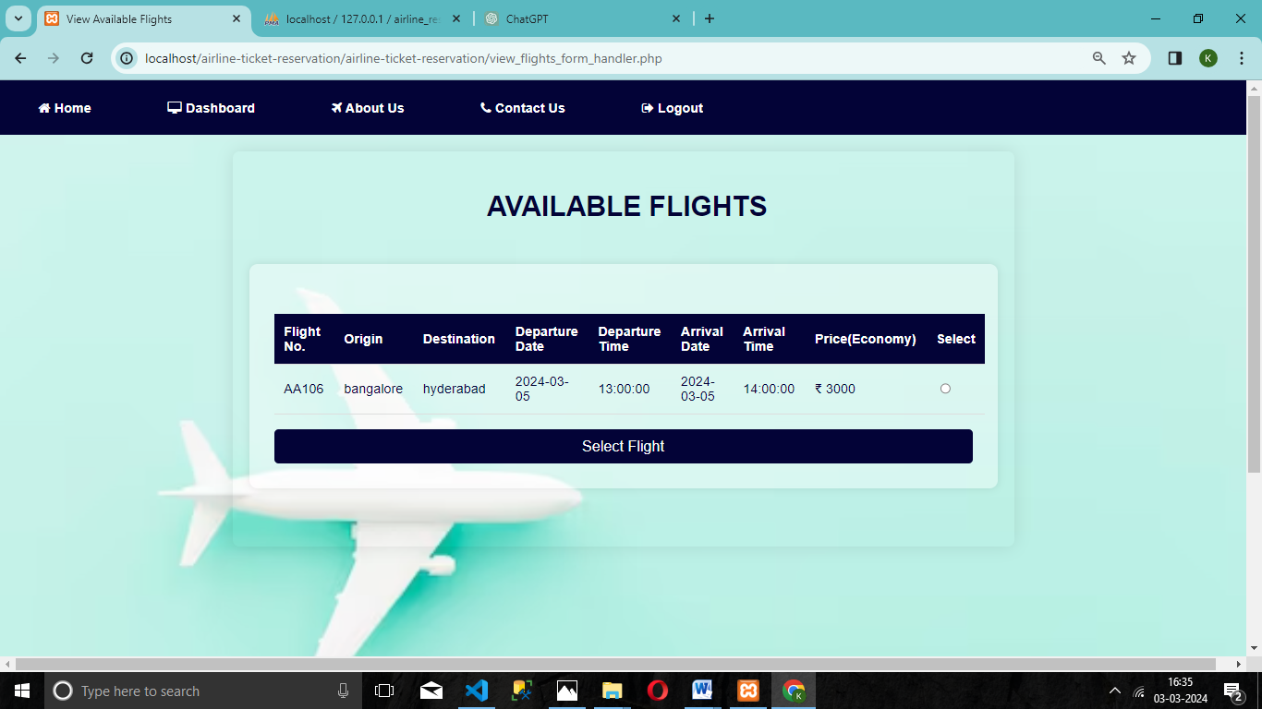

**Fig6.5** View flight details page

**6.6Payment details page**

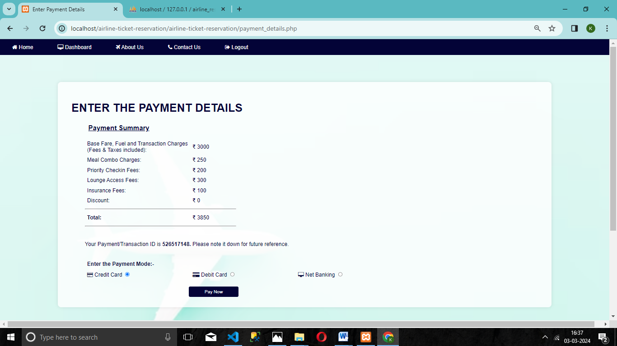

**Fig6.6** Payment details page

**6.7 booking success page**

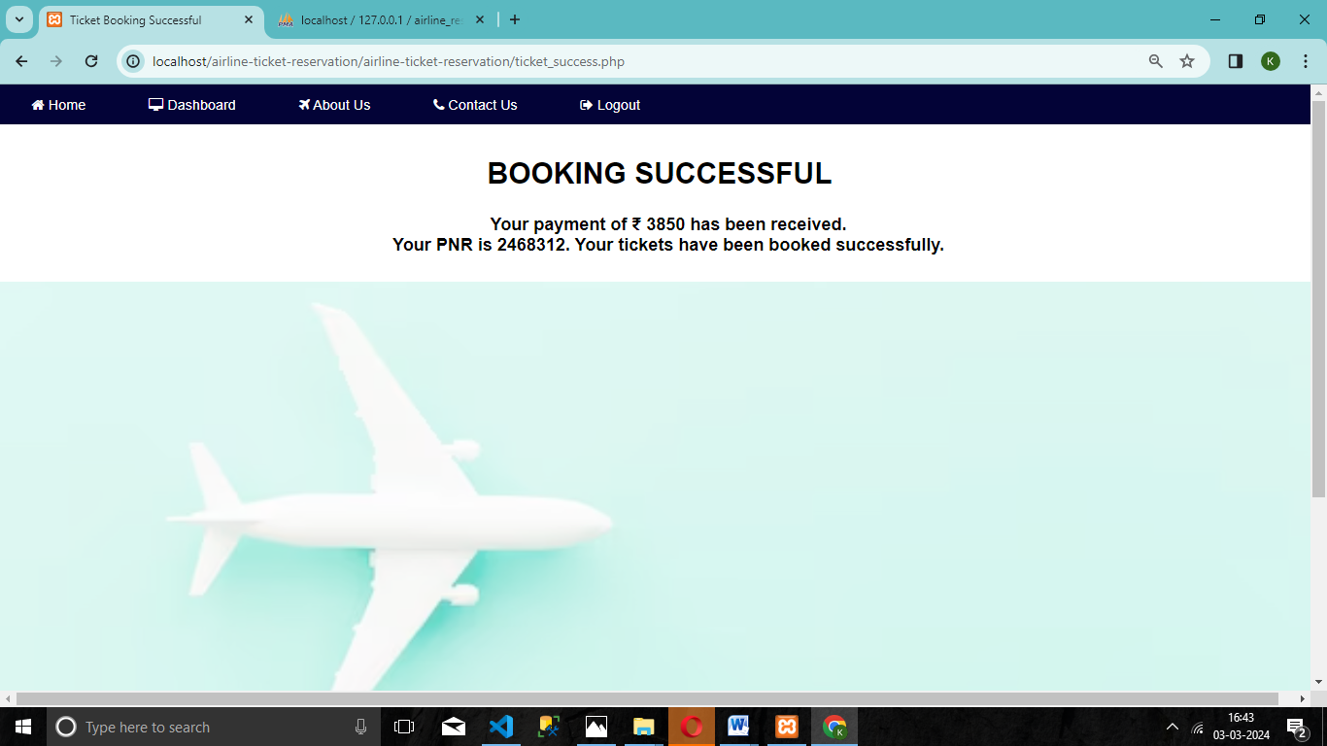 **Fig6.7** booking success page

**6.8 Pnr check page**

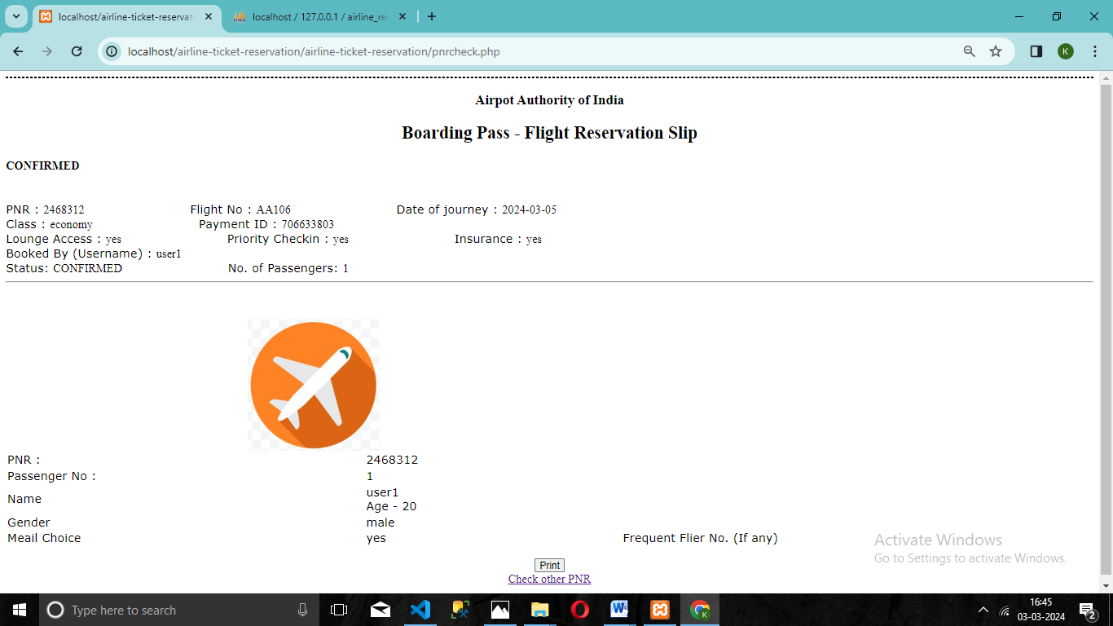

**Fig6.8** Pnr check page

**6.9 Cancel booked ticket page**

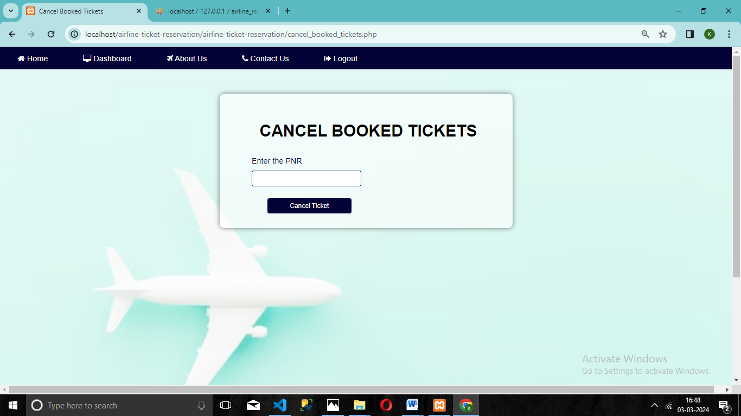 **Fig6.9** cancel booked ticket page

**6.10 Admin home page**

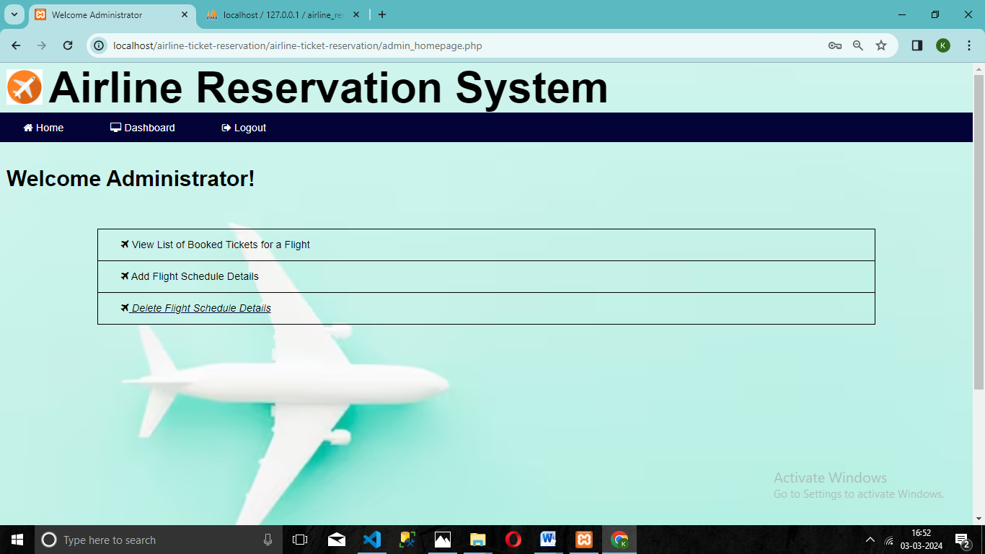

**Fig6.10** Admin home page

**6.11 Admin add flight page**

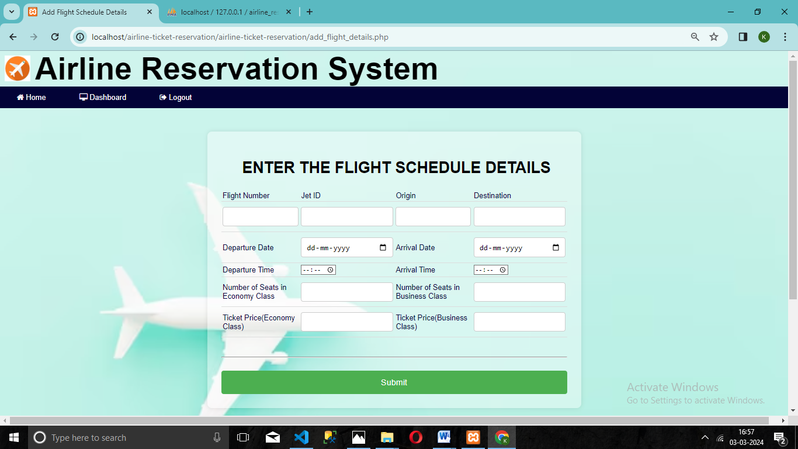

**Fig6.11** Admin add flight page

**6.12 Admin delete flight details page**

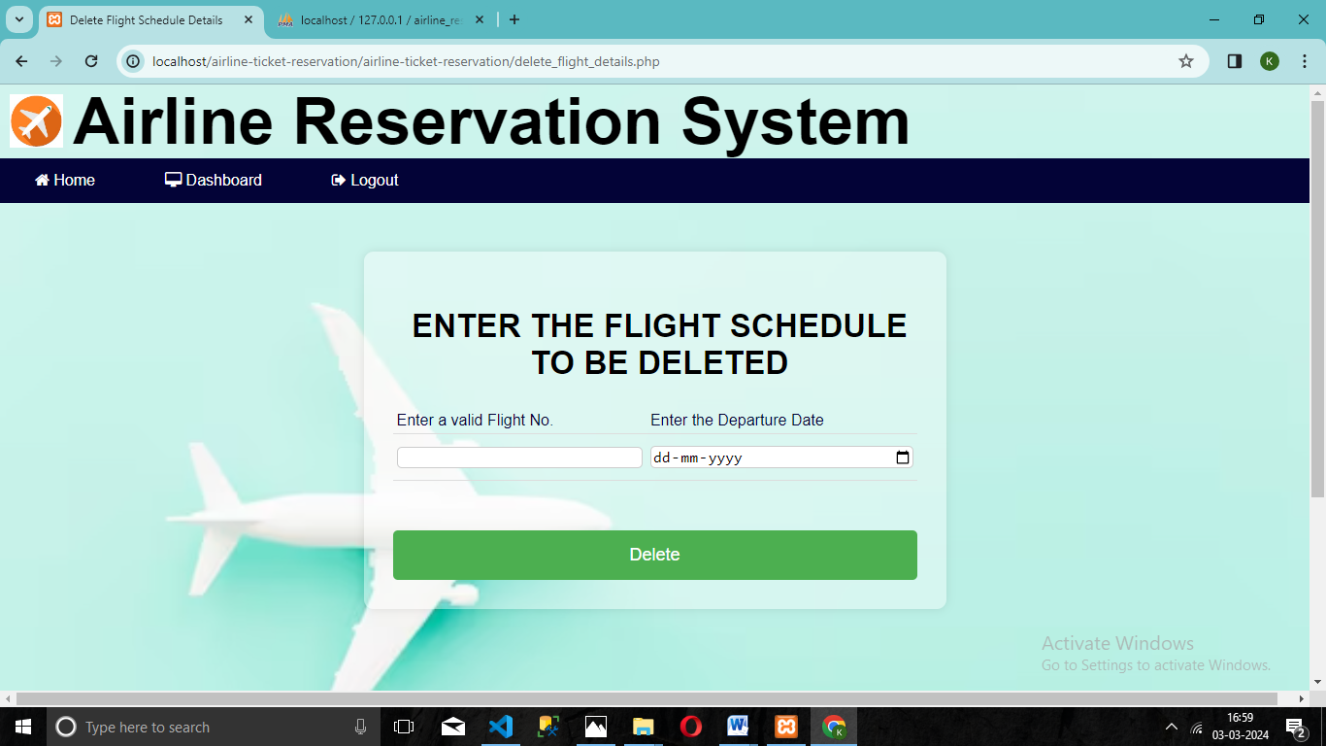

**Fig6.12** Admin delete flight details page

# CONCLUSION

The Airline reservation system has been a way of minimizing the clerical work, which is almost a routine and consumes the most precious time. This AIRLINE RESERVATION SYSTEM has been an attempt to help the user to minimize his workload along with minimizing the paper works and saving of time .The system has been developed in a way to make it very user friendly.

It provides an on-line message and an error detection and error messages every time the user needs. Any person having a little bit of window based can run this system without any pain.. The System has reached a steady state where all bugs have been eliminated. The system is operated at a high level of efficiency and all the teachers and user associated with the system understands its advantage. The system solves the problem. It was intended to solve as requirement specification.

The project greatly helped in understanding the various phases in website development and exposure to a new developer platform using php, html and database My SQL**.**

# FUTURE ENHANCEMENT

Although the project work has been done in a complete and detailed manner but due to the constraints of time, we could not include some more features we wanted to. We left these features as a part of the future development. As soon as we‘ll get time we’ll try to add them to my project.

As a FUTURE ENHANCEMENT we have decided to further enhance with a seat reservation available.

It is to fulfill passengers request to sit where they prefer. They are allowed to choose their seat whether near to window’s seat or in the middle.

### References URL’S:

**BIBLIOGRAPHY**

1. [www.w3schools.com](http://www.w3schools.com/)
2. [www.tutorialspoint.com/mysql/](http://www.tutorialspoint.com/mysql/)

### Reference Books:

1. Elmasri Navathe - “Fundamentals of Database System “, 2017[7th Edition]
2. Ramakrishnan and Gehrke - “Database Management System” 2014[3rd Edition]
3. Bipin Desai – “An Introduction to Database System “
4. Thomas A. Powell – “HTML and XHTML: The Complete Reference”
5. Kevin Yank – “PHP & MySQL Novice to Ninja “